**Lab21**

**Cloud Formation – LAMP stack**

**Click “Cloud formation”.**

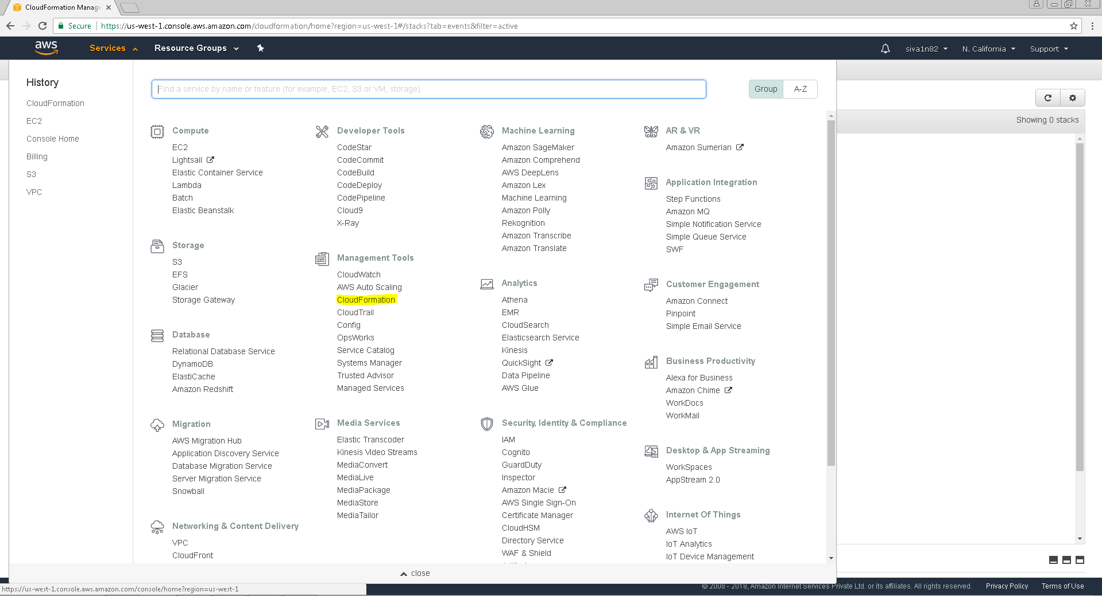

**Click “Create new stack”.**

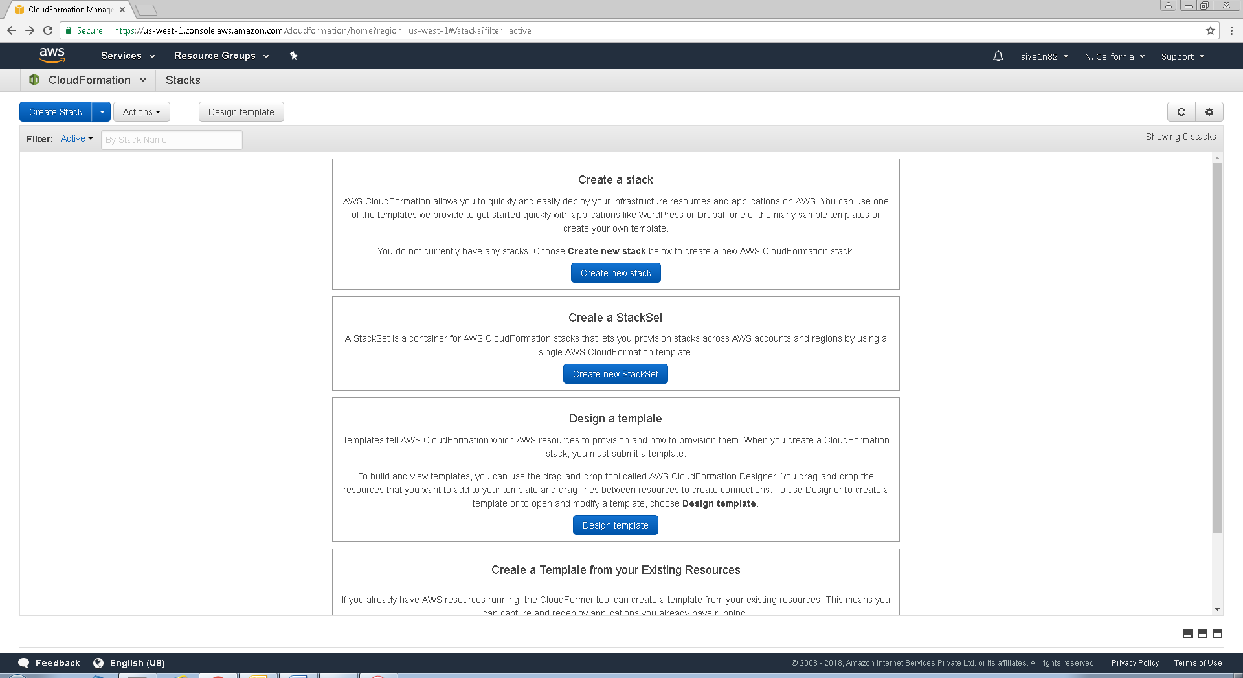

**In Select a sample template, click drop down box.**

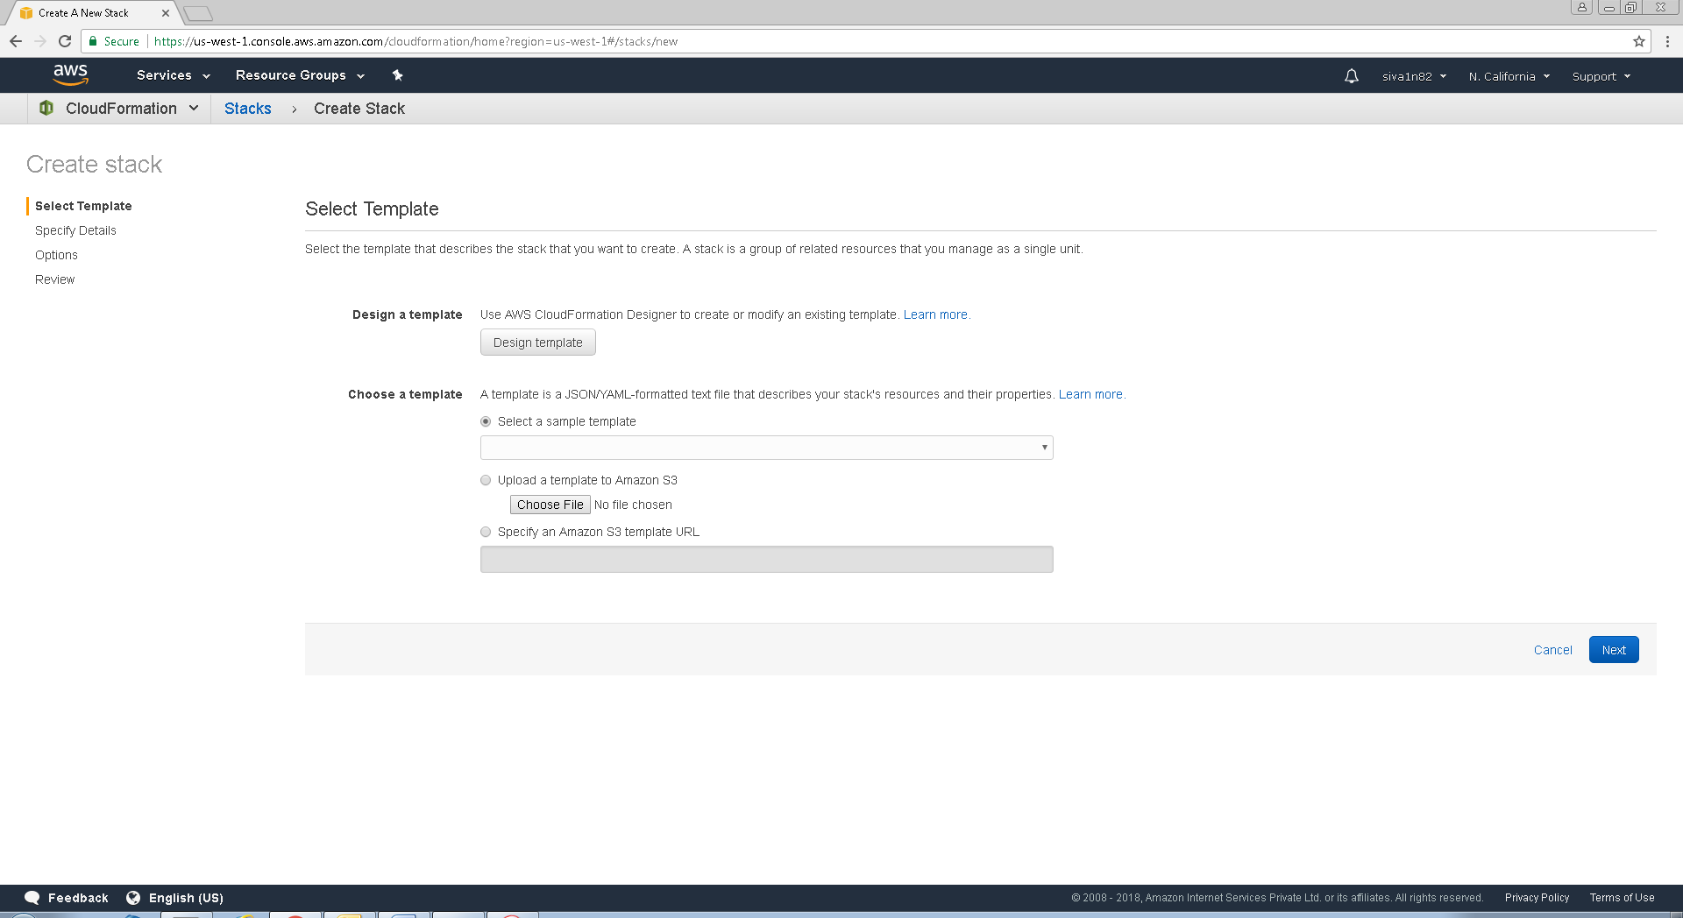

Click “Lamp stack”.

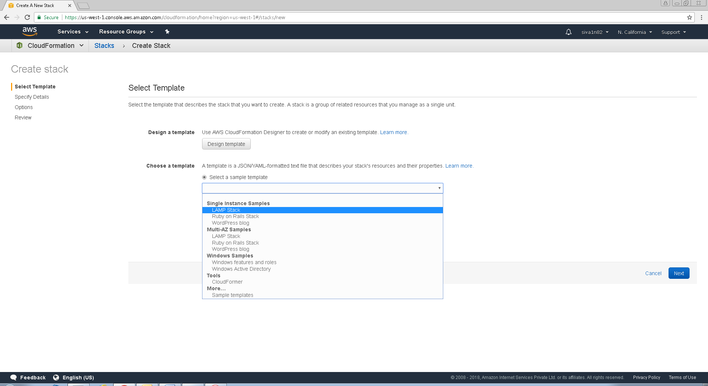

Specify stackname as sansLamp, DBPassword and user. Select t2.micro, choose key name and ssh location as 0.0.0.0/0

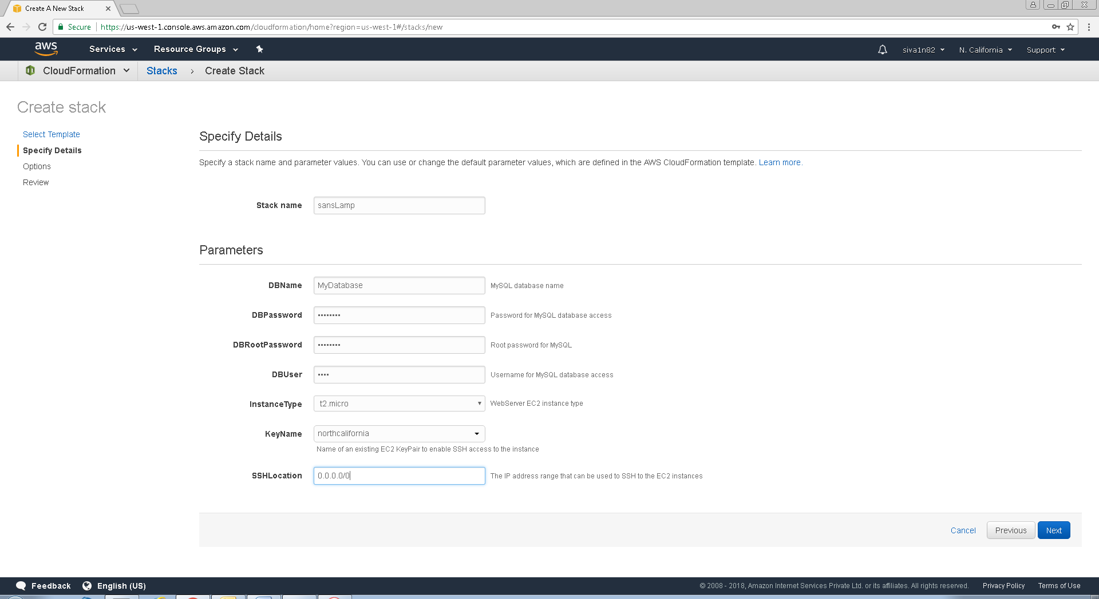

.

Click “Next”.

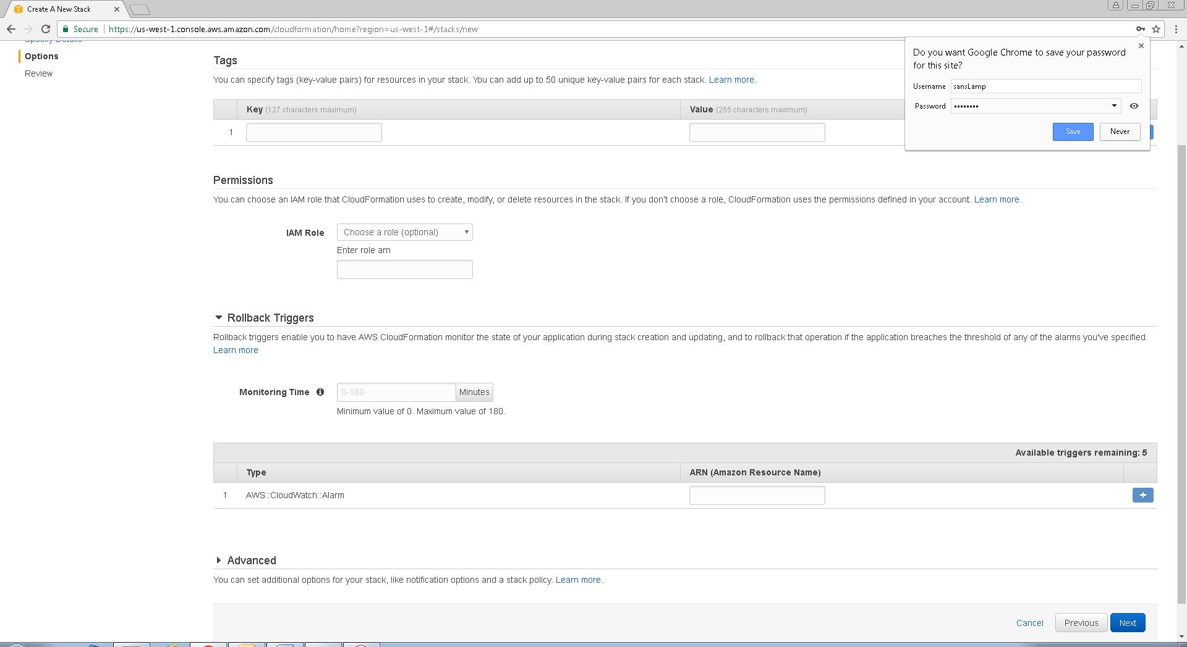

Click “Create”.

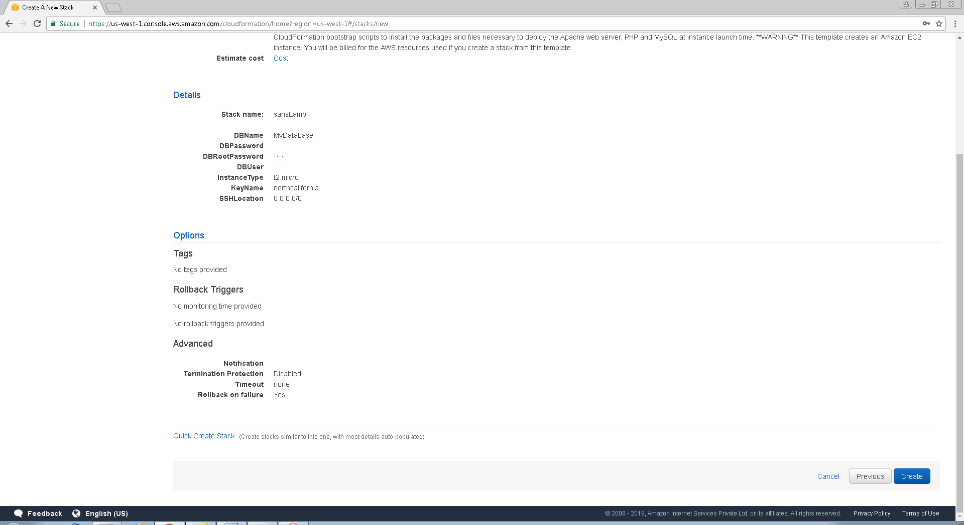

Creation in progress

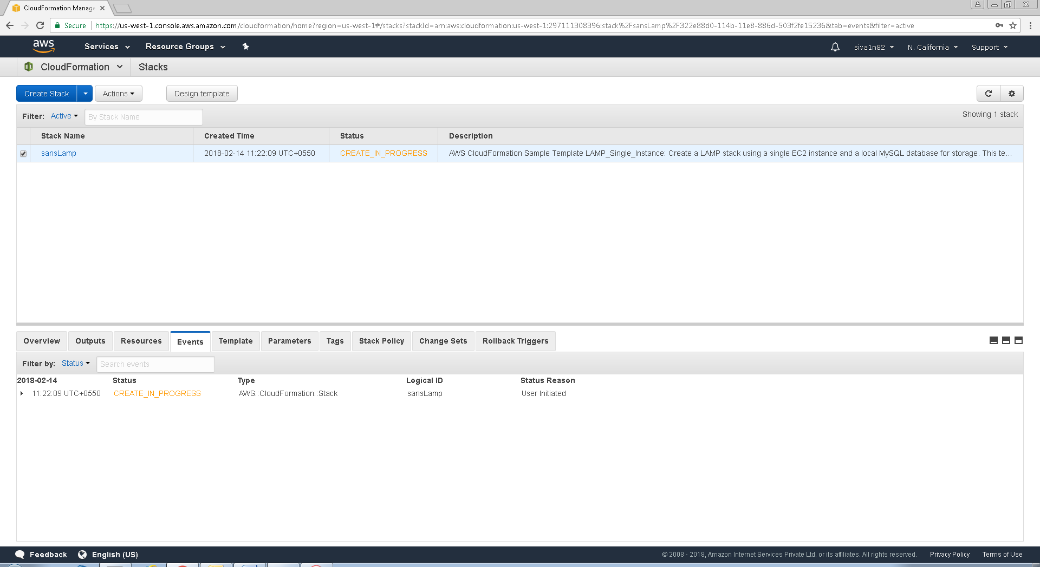

Lamp stack has been successfully created.

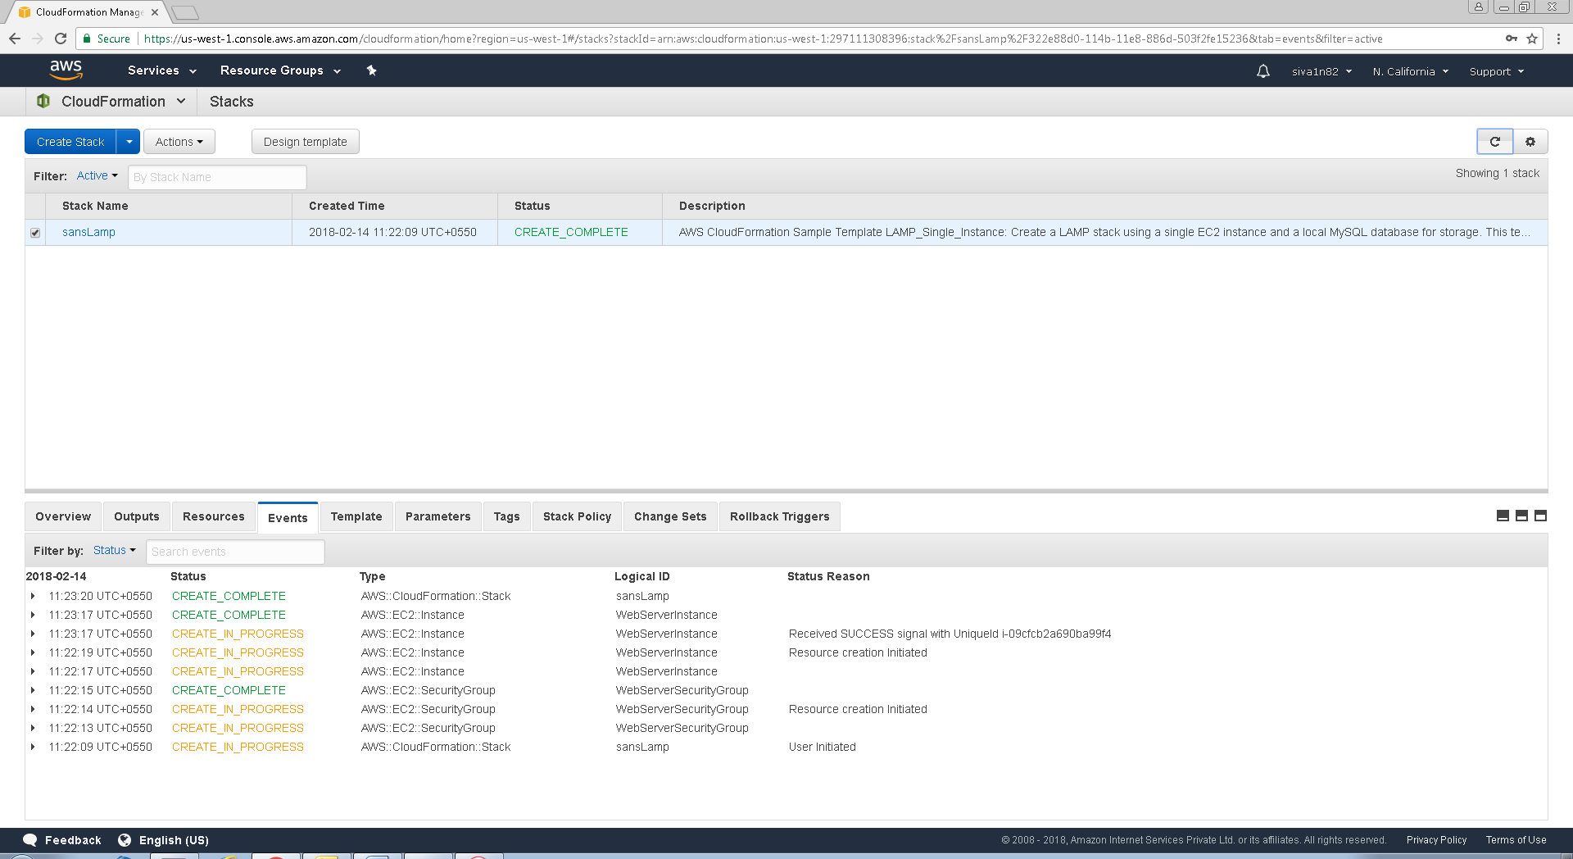

Go to instance, one instance has been created.

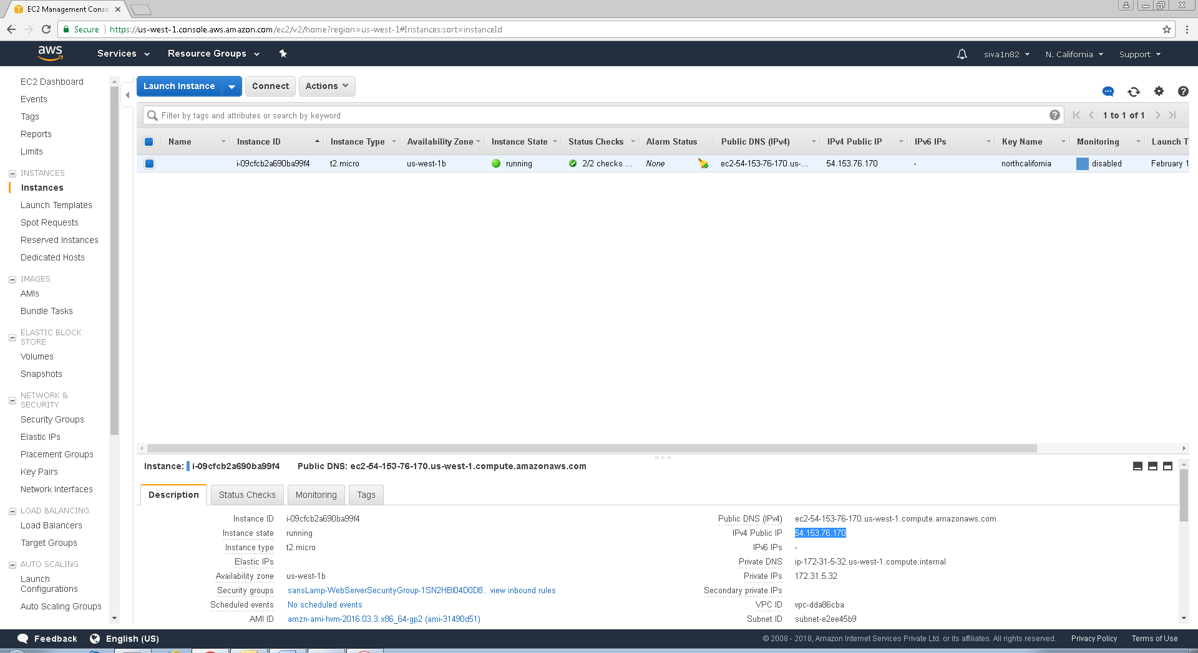

Try to connect webserver, we have got the web page successfully.

